DEPARTMENT OF COMPUTER SCIENCE AND ENGINEERING
CSA05-DATABASE MANAGEMENT SYSTEMS
SELECT with various clause – GROUP BY, HAVING, ORDER BY
EXPERIMENT – 7
GROUP BY – HAVING
- How many students are registered for each course? Display the course description and the number of students registered in each course.
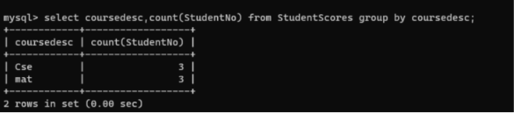

- How many courses did each student register for?
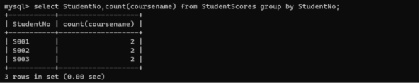
ORDER BY
- Retrieve Name, Gender, Mobile No of all the students in ascending order of Reg No.
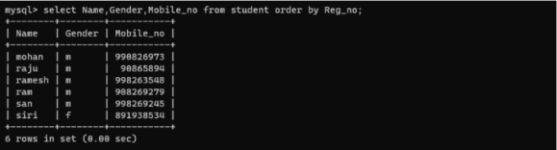
- List the faculty members in the order of older faculty first.
